Assignment 3
Q 1
<!DOCTYPE html>
<html lang="en">

<head>
<meta charset="UTF-8">
<meta name="viewport" content="width=device-width, initial-scale=1.0">
<link rel="stylesheet" href="bootstrap-5.3.8/dist/css/bootstrap.min.css">
<title>Document</title>
</head>

<body>
<div class="container-fulid">
<div class="row m-5">
<div class="col-md-4 bg-light p-3 border">COL 1</div>
<div class="col-md-4 bg-light p-3 border">COL 2</div>
<div class="col-md-4 bg-light p-3 border">COL 3</div>
<div class="col-md-4 bg-light p-3 border">COL 4</div>
</div>
</div>
<div class="container">
<div class="row m-5">
<div class="col-md-3 col-lg-4 col-xl-6 col-sm-6 bg-light border p-3 ">COL 1</div>
<div class="col-lg-4 col-md-3 col-xl-6 col-sm-6 bg-light p-3 border">COL 2</div>
<div class="col-md-3 col-lg-4 col-xl-6 col-sm-6 bg-light p-3 border">COL 3</div>
<div class="col-md-3 col-lg-4 col-xl-6 col-sm-6 bg-light p-3 border">COL 4</div>
</div>
</div>

</body>

</html>
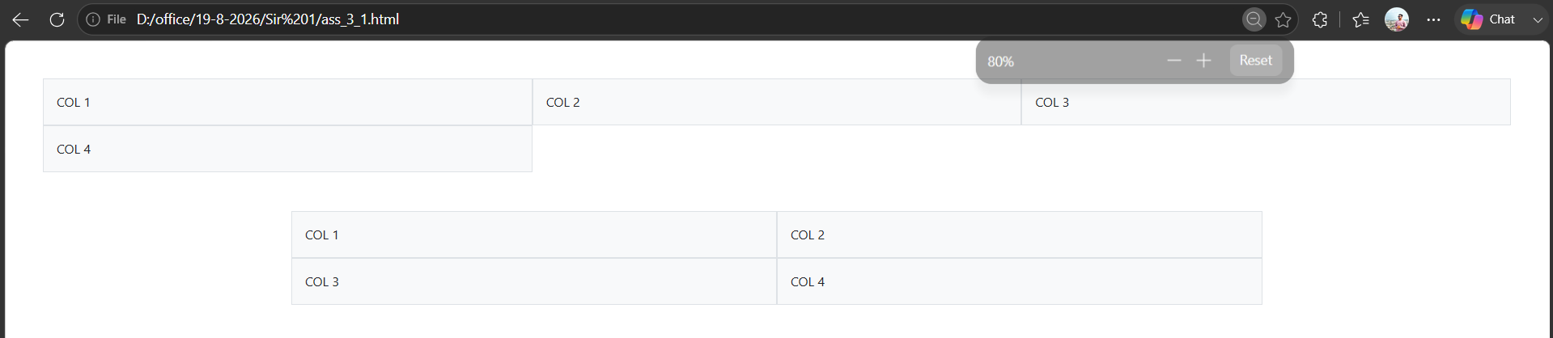
Q 2
<!DOCTYPE html>
<html lang="en">

<head>
<meta charset="UTF-8">
<meta name="viewport" content="width=device-width, initial-scale=1.0">
<link rel="stylesheet" href="bootstrap-5.3.8/dist/css/bootstrap.min.css">

<title>Document</title>
</head>

<body>
<div class="container">
<div class="table-responsive m-1">
<table class="table table-stiped table-hover">
<thead>
<tr>
<th scope="col">Row</th>
<th scope="col">Header</th>
<th scope="col">status</th>
</tr>
</thead>
<tbody>
<tr>
<th scope="row" >1</th>
<td>Data 1</td>
<td>Striped</td>
</tr>
<tr>
<th scope="row">2</th>
<td>Data 2 </td>
<td>Hover</td>
</tr>
<tr class="table-danger">
<th scope="row">3</th>
<td>Data 3 </td>
<td>Hover</td>
</tr>
<tr class="table-primary">
<th scope="row">4</th>
<td>Data 4 </td>
<td>Hover</td>
</tr>
</tbody>
</table>
</div>
</div>

</body>

</html>
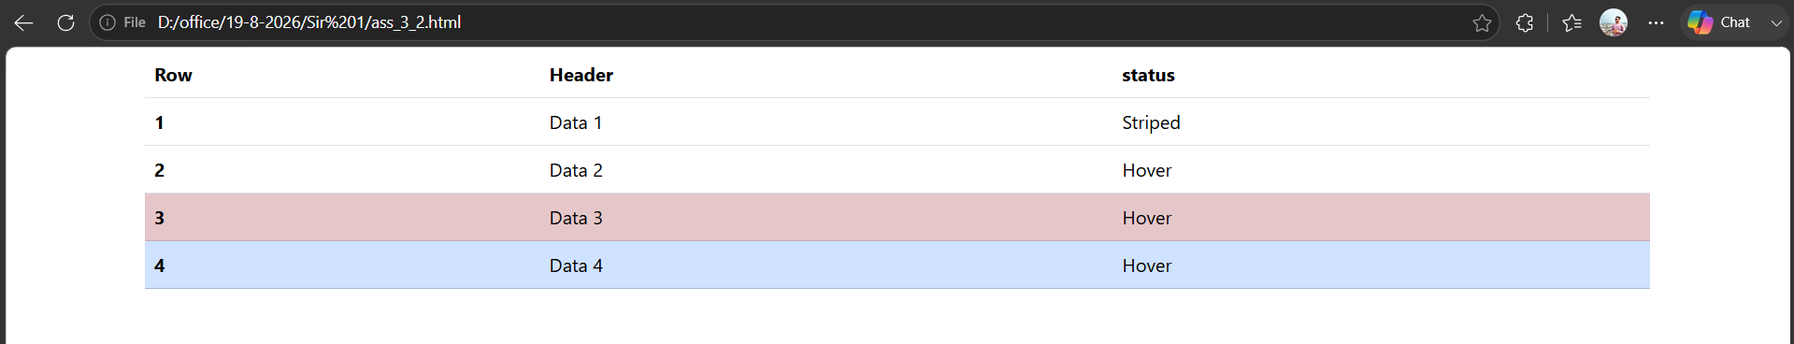
Q 3
<!DOCTYPE html>
<html lang="en">

<head>
<meta charset="UTF-8">
<meta name="viewport" content="width=device-width, initial-scale=1.0">
<link rel="stylesheet" href="bootstrap-5.3.8/dist/css/bootstrap.min.css">
<style>
*{
margin: 0px;
padding: 0;
}
</style>
<title>Document</title>
</head>

<body>
<div class="container">
<div class="container">
<button type="button" class="btn btn-primary m-1">Primary</button>
<button type="button" class="btn btn-secondary m-1">Secondary</button>
<button type="button" class="btn btn-success m-1">Success</button>
<button type="button" class="btn btn-warning">Warning</button>
<button type="button" class="btn btn-danger">Danger</button>
<button type="button" class="btn btn-primary btn-sm m-1">Primary</button>
<button type="button" class="btn btn-lg btn-primary m-1">Primary</button>
</div>

<div class="container">
<div class="alert alert-warning m-1">Coution! This is a warning alert.</div>
<div class="alert alert-danger m-1">Coution! This is a warning alert.</div>
<div class="alert alert-success m-1">Coution! This is a warning alert.</div>
</div>

<div class="container">
<p class="text-primary m-1">Primary Text</p>
<p class="text-danger m-1">Danger Text</p>
</div>
<div class="bg-success text-white m-1 p-3">Success Background Box</div>
</div>
</body>

</html>
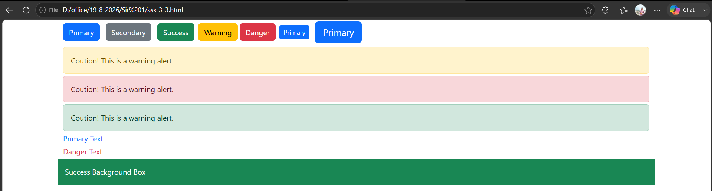
Q 4
<!DOCTYPE html>
<html lang="en">

<head>
<meta charset="UTF-8">
<meta name="viewport" content="width=device-width, initial-scale=1.0">
<title>Document</title>
<link rel="stylesheet" href="bootstrap-5.3.8/dist/css/bootstrap.min.css">
</head>

<body>
<div class="container">
<div class="m-5">
<label class="form-label text-dark">Your Name</label>
<input type="text" class="form-control" id="name" placeholder="Enter Name">
</div>
</div>

</body>

</html>
